Euglena Ehrenberg 1830
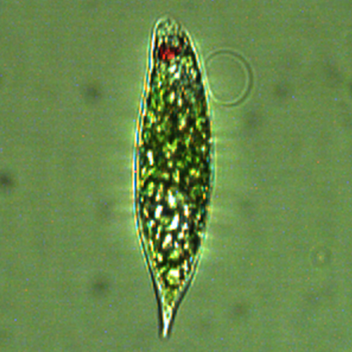
Phylum: Euglenophyta
Class: Euglenophyceae
Order: Euglenales

Habitat: plankton, mostly littoral
Distinctive features: large, flagellated cells (only 1 flagellum can be seen), mixotroph, changes shape continuously. Distinct red eyespot.
Organization: single flagellated cells
Color: grass-green
Cell shape: a flattened drop of water
Cell diameter (D): 13-19 μm, median 10 μm (N=173)
Cell length (L): length 28-53 μm, median 27 μm (N=173)
Cell biovolume: 500 - 9000 μm³, median: 1200 μm³.
Biovolume equation: prolate spheroid V = 4/3 π (D/2)² L/2

Morphological features:
Euglena is the most common euglenoid genus worldwide. It is a large, flagellated algae with a distinct orange-red eyespot. The motile cells are ovoid-cylindrical to narrowly fusiform, frequently with a narrow, elongated posterior caudus (“tail”), and may change their shape while they move under the microscope. Euglena has a single flagellum used for swimming, and a second very short flagellum that is not seen under a light microscope. The cells can turn spherical by an end-to-end contraction, followed by a quick expansion. They are also capable of actively contorting themselves in a variety of shapes through peristaltic-like motions, as well as twisting around an apical axis. The orange to red colored eyespot, noticeable near the base of the flagellum, is much larger than the eyespot in flagellated green algae. A single vacuole, capable of contracting, may be conspicuous when it is expanded. The shape, number and position of the chloroplasts along with the presence or absence of pyrenoids were traditionally key taxonomic features along with cell size and apical shapes. In apical view Euglena is circular although at times it could be twisted.
Several species of Euglena occur in Lake Kinneret, including E. proxima (Plates 1, 2) and E. acus (Plate 3, now considered a synonym of Lepocynclis acus). In our routine counts all species of Euglena are aggregated into a single counting code.

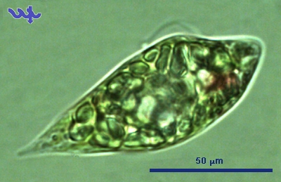
Plate 1. Euglena proxima, one of several species of Euglena occurring in the plankton of Lake Kinneret, mostly in the littoral zone. With numerous disk-shaped chloroplasts and a conical colorless caudus (=tail piece). Photo by Alla Alster.
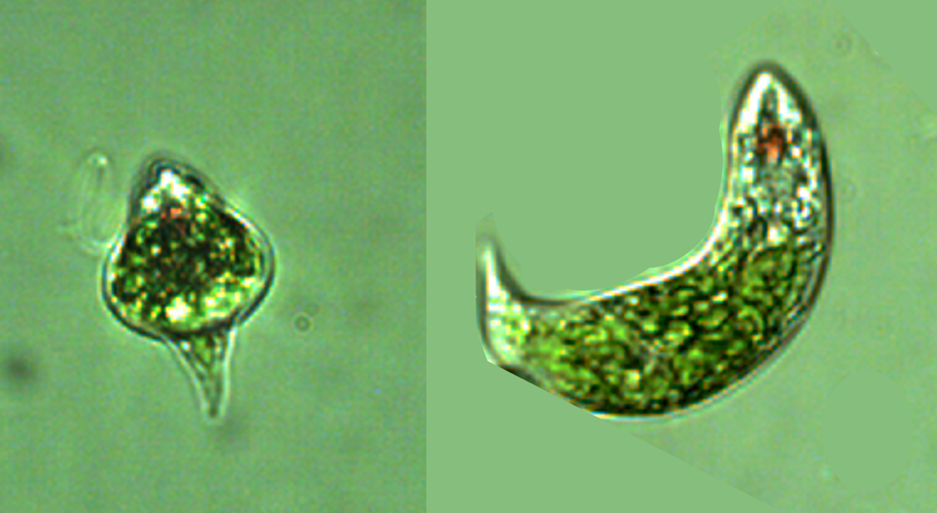
Plate 2. Euglena proxima continuously changes its shape. Note coiled flagellum on left image. Photos by Alla Alster.
Plate 3. Euglena acus from Lake Kinneret, now a synonym of Lepocynclis acus. With a distinct red eyespot and elongated caudus (tail). Several long cylinder-shaped organelles in the front part of the cell are paramylon bodies in which paramylon (colorless polysaccharides) are stored.

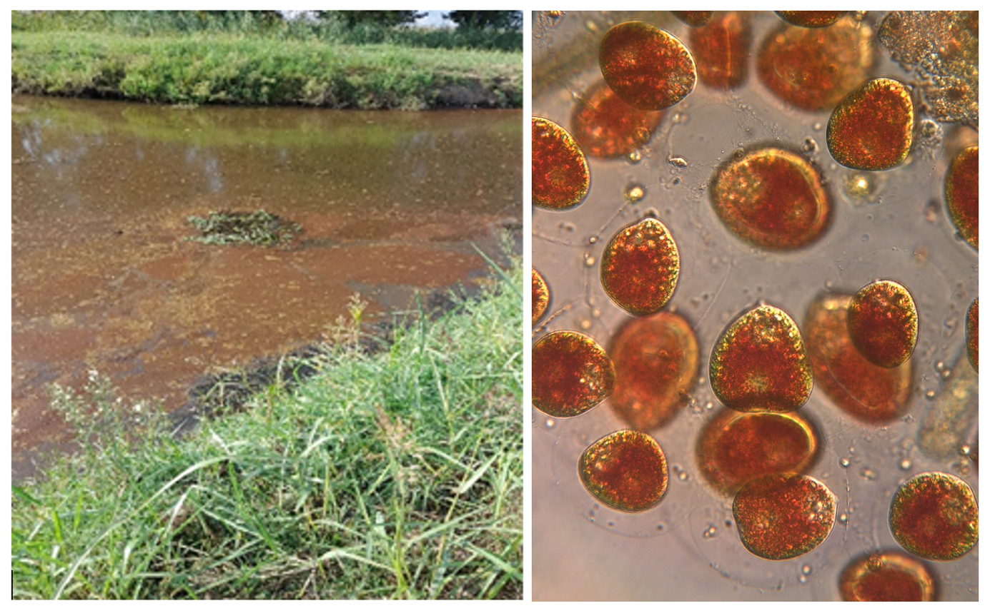
Plate 4. Left: Reddish-brown water due to an intense Euglenophyte bloom in the Agmon Wetland, Hula Valley, 31 October 2022. Photo by Dana Klein. Right: microscope photo of the dominant bloom species, Euglena sanguinea Ehrenberg 1832. Photo by Alla Alster.
Ecology: Euglena spp. are rare in the Kinneret pelagic zone, but occasionally abundant in littoral samples, especially if collected from niches with high concentrations of organic matter, such as shallow waters among seasonally inundated shore vegetation, or temporary shore-pools created in bottom depressions with decomposing vegetation when the water level declines at a fast pace. In Agmon Wetlands in the peat soils of the Hula valley, Euglena species (as well as other Euglenoids) are much more abundant than in Kinneret. Occasionally, the toxin-producing Euglena sanguinea forms massive blooms that paint the surface water red (Plate 4). The distinctive euglenoid pigment astaxanthin is responsible for the distinctive red color.
Physiological features: Strongly phototactic. Conducts vertical migrations.
Environmental conditions: The cell abundance data shown in Figs. 1, 2 are for a sum of individuals belonging to the Euglena genus recorded at the pelagic water of Lake Kinneret. Euglena spp. abundance was indifferent to chloride concentrations, Secchi depth, TDP, DON. Higher cell concentrations were found in summer (Fig. 1), at higher water temperatures (> 25°C), when the mixing depth ranged 15-20 m, dissolved oxygen between 6-8 mg L⁻¹ (Fig. 2), pH between 8.0 and 8.6, NH₄ < 0.06 mg N L⁻¹, Organic N between 0.2-0.4 mg N L⁻¹ (not shown).
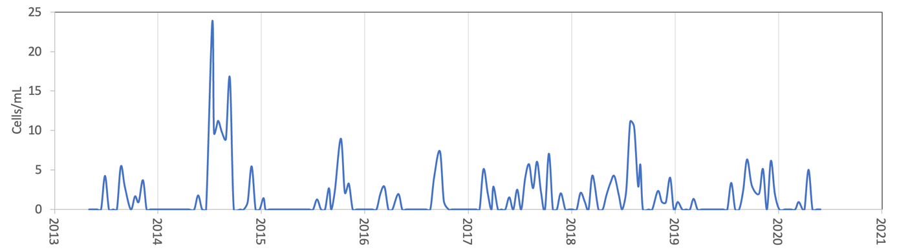
Figure 1. Time series of Euglena spp. abundance (average water column cells mL⁻¹), Sta. A, Lake Kinneret, 2013-2020.
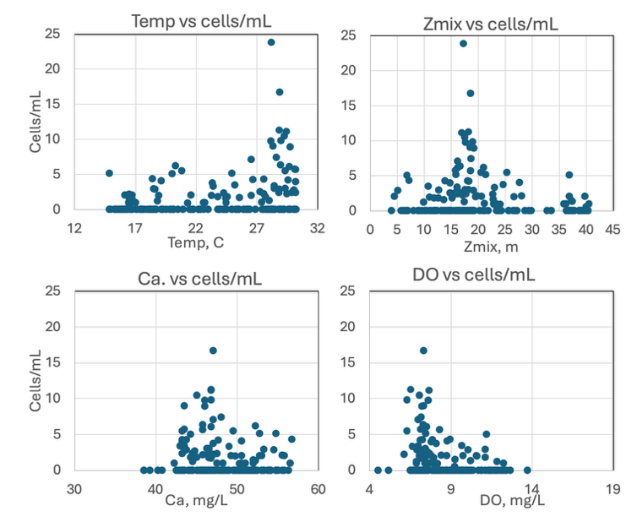
Figure 2. Euglena spp. abundance (cells mL⁻¹) vs. environmental parameters recorded at the site and time of sampling, showing tendency for higher cell concentrations at higher water temperature, lower dissolved oxygen (DO), Mixing depth of 15-20 m, Ca > 42 mg L⁻¹.
Cite this record as:
Tamar Zohary, Alla Alster. [Date when Item was last updated]. Electronic publication. Israel Oceanographic & Limnological Research. [Date when last accessed].
Further reading:
Dillard, G.E. (2000). Freshwater algae of the southeastern United States, Part 7. Pigmented Euglenophyceae. Bibliotheca Phycologica 106: 1–135.
Wołowski, K. (2011). Euglenophyta (Euglenoids). In: The freshwater algal flora of the British Isles. An identification guide to freshwater and terrestrial algae. Second edition. (John, D.M., Whitton, B.A. & Brook, A.J. Eds), pp. 181-239. Cambridge: Cambridge University Press.

Phacus longicauda (Ehrenberg) Dujardin 1841
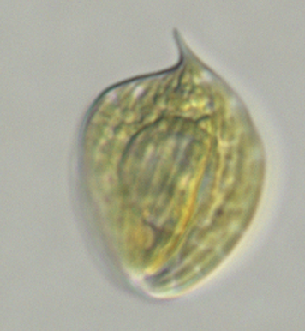

Phylum: Euglenophyta
Class: Euglenophyceae
Order: Euglenales

Habitat: plankton/benthos, littoral
Distinctive features: elegant swimming, striped and thin like a sheet of paper, with distinct eyespot and a sharply pointed tail. Rare – never counted in our samples.
Organization: flagellated single cells
Color: grass green
Cell shape: leaf-shaped

Morphological features:
Phacus species (see thumbnail photo) are single-celled, grass-colored, leaf-shaped (i.e. flat and very thin), often twisted, with straight or slightly bent sharply pointed caudus (or ‘tail’). It is striped, all the stripes start at the flagellum opening and end in the ’tail’ covering the cell like longitude lines covering a globe. With numerous discoid chloroplasts, no pyrenoids. Phacus does not change its shape like Euglena does. The cells are motile, their locomotion flagellum emerges from a canal at the top side of the cell. A second flagellum is very short and not emerging, cannot be seen by light microscopy. A red eyespot is usually seen near the top of the cell. One or two large paramylon (a carbohydrate) storage body is often seen as an elongated white body.
Ecology: Phacus species are extremely rare in Lake Kinneret. They have never been abundant enough to be counted in our routine monitoring, but occasionally a specimen is found in the littoral zone, usually of the species Phacus longicauda (Plate 1) or Phacus caudatus.
Plate 1. Phacus longicauda from the littoral zone of Lake Kinneret, Jan 2008. Showing red eye spot, elongated tail (=longicauda), large lighter-color nucleus at the cell center, typical stria (stripes). Photo by Alla Alster.
Cite this record as:
Tamar Zohary, Alla Alster. [Date when Item was last updated]. Electronic publication. Israel Oceanographic & Limnological Research. [Date when last accessed].
Further reading:
Dillard, G.E. (2000). Freshwater algae of the southeastern United States, Part 7. Pigmented Euglenophyceae. Bibliotheca Phycologica 106: 1–135.
Wołowski, K. (2011). Euglenophyta (Euglenoids). In: The freshwater algal flora of the British Isles. An identification guide to freshwater and terrestrial algae. Second edition. (John, D.M., Whitton, B.A. & Brook, A.J. Eds), pp. 181-239. Cambridge: Cambridge University Press.

Trachelomonas Ehrenberg 1833
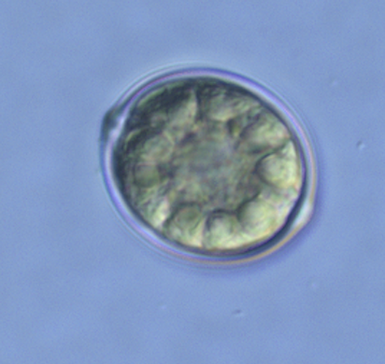
Phylum: Euglenophyta
Class: Euglenophyceae
Order: Euglenales

Habitat: plankton, pelagic
Distinctive features: Near-spherical flagellated cells encapsulated in a brown lorica with a distinctive “mouth” opening through which the locomotive flagellum emerges.
Organization: single flagellated cells
Color: brown
Cell shape: spheroid
Cell diameter (D): 8.9-15.5 μm (median=11.4 μm). Range reported is 5th-95th percentiles for 234 cells measured during 2004-2009.
Cell Biovolume: 370 - 2000 μm³, median: 800 μm³.
Biovolume equation: sphere, V = ¾ π (D/2)³

Morphological features:
Trachelomonas cells are like those of Euglena, except that they are completely encased in a mucilaginous rigid case outside the plasma membrane called lorica (Plates 1, 2). This lorica is highly mineralized and dark brown in color (Plates 2, 3). The cell is flagellated and capable of euglenoid movement within the lorica as well as swimming out of it (Plate 2). The lorica has a bottle-neck-shaped opening through which the flagellum emerges and through which the cell may swim out for cell division or when conditions require, then may swim back into it.
Trachelomonas is distinguishable from other spherical unicellular species occurring in Lake Kinneret by the bottle-neck-shaped opening of its lorica, at the top part of the cell (arrow in Plate 1). This structure can be seen only when the cell is observed from the side, not when it is observed from above or below.
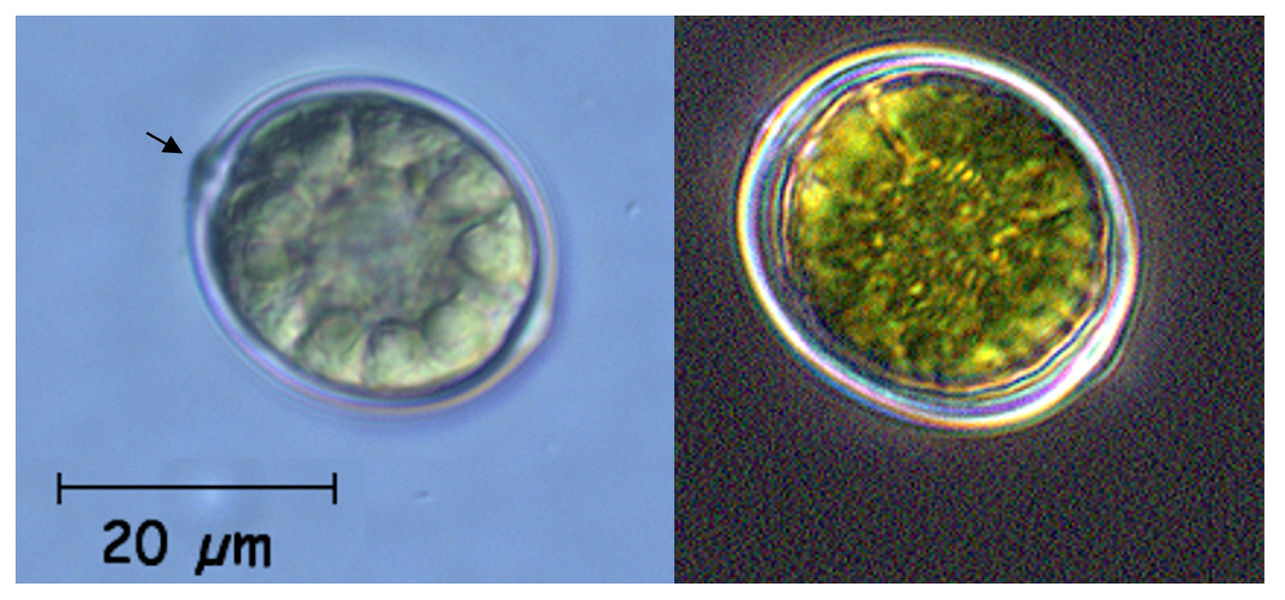
Plate 1. Typical Trachelomonas: a euglenoid cell encapsulated by a thick lorica. Left: bright field; Many chlorophytes arranged around cell periphery, large circular nucleus in it center. Arrow indicates the protruding opening of the lorica from which the flagellum extends (but is not seen here). Right: dark field. Photos by Tamar Zohary.
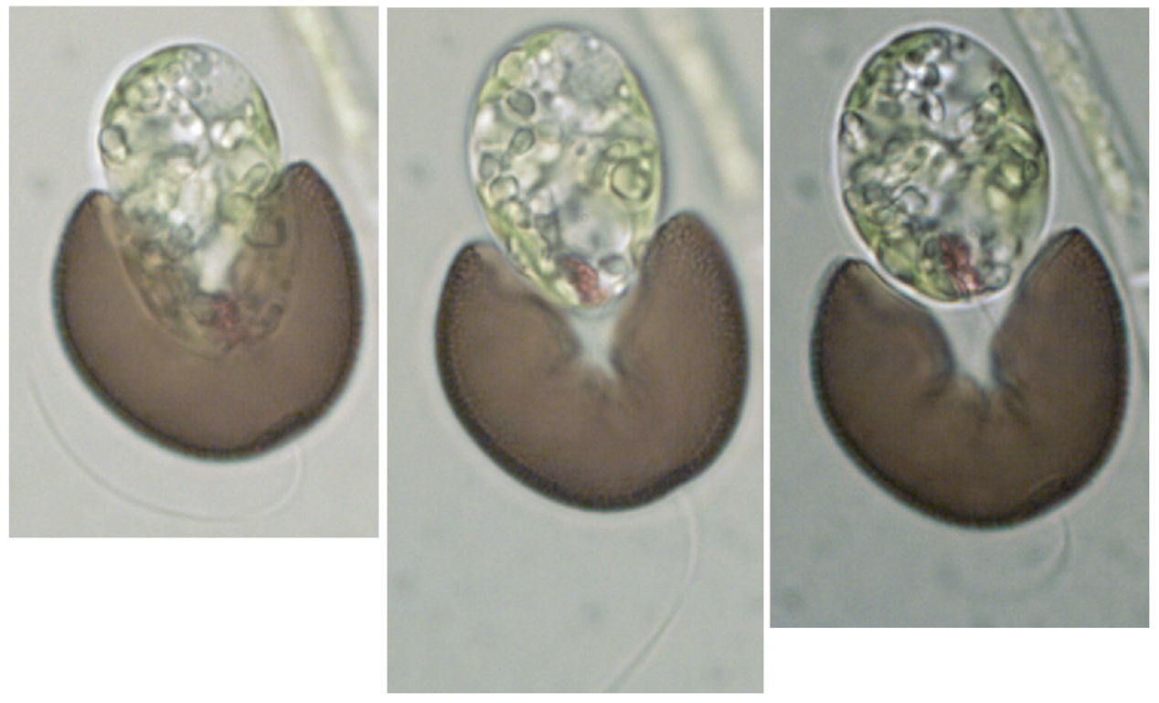
Plate 2. Trachelomonas hispida (Perty) Stein 1878 from Lake Kinneret. The Euglena-like cell is exiting its brown-colored lorica. The single flagellum is seen extending though an opening in the lorica at its bottom end. Photos by Alla Alster.
Plate 3. Trachelomonas hispida inside its brown case, as usually seen in our pelagic samples.
Ecology: Trachelomonas is the only euglenoid seen in Kinneret pelagic plankton samples quite often, although this genus too is never abundant, maximum cell density ever recorded was ~50/mL (Fig. 1). Trachelomonas can be viewed at any time of the year but tends to appear more often in spring (March-April) and rarely from August to October (Fig. 2). Cell size varies only slightly, with no distinct annual pattern (Fig. 2).
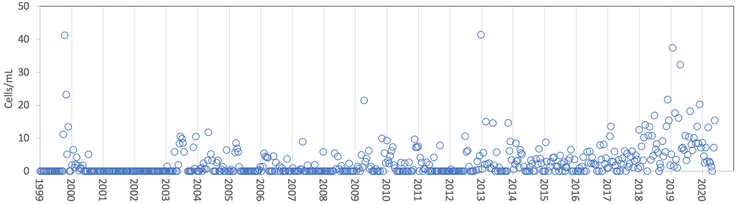
Figure 1. Time series of Trachelomonas spp. abundance (cells mL⁻¹), Lake Kinneret, 1999-2020.
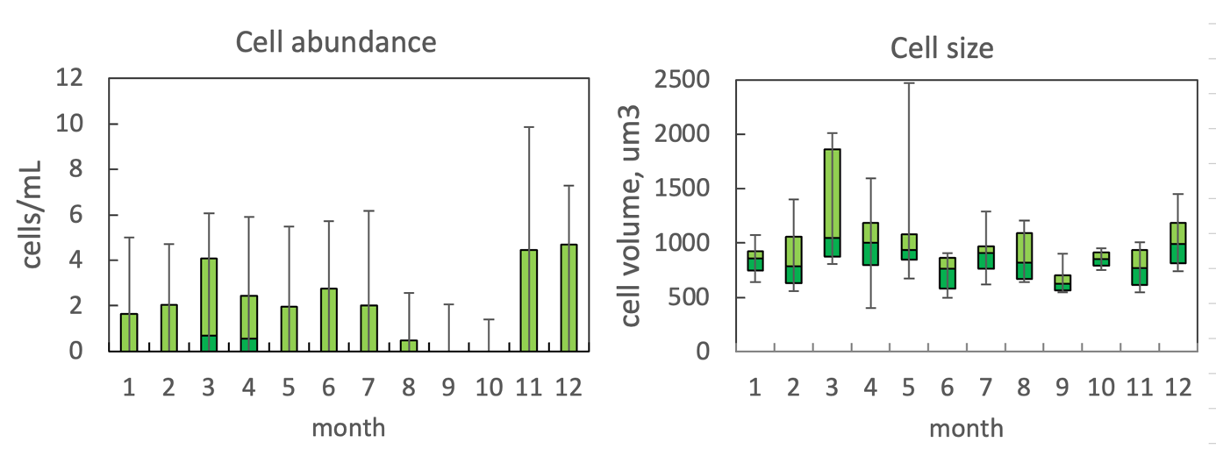Figure 2. The annual pattern of water column cell abundance (left) and volume per cell (right) of Trachelomonas spp., based on data for 1999-2014. Statistics shown: median – middle line; 25th to 75th percentiles – box content; 90th and 10th percentiles – top and bottom bars, respectively.
Environmental conditions: The abundance of Trachelomonas spp. in the pelagic water of Lake Kinneret was indifferent to water temperature, ambient chloride concentration (Fig. 3), water level, pH, Ca, Alkalinity, Si, NO₃, NH₄ and Z_{mix}/Z_{eu} ratio (not shown). Higher abundances of the genus were recorded when depth-integrated (0-15 m) chlorophyll concentrations were < 500 mg m⁻², and organic N > 0.15 mg N L⁻¹ (Fig. 3).
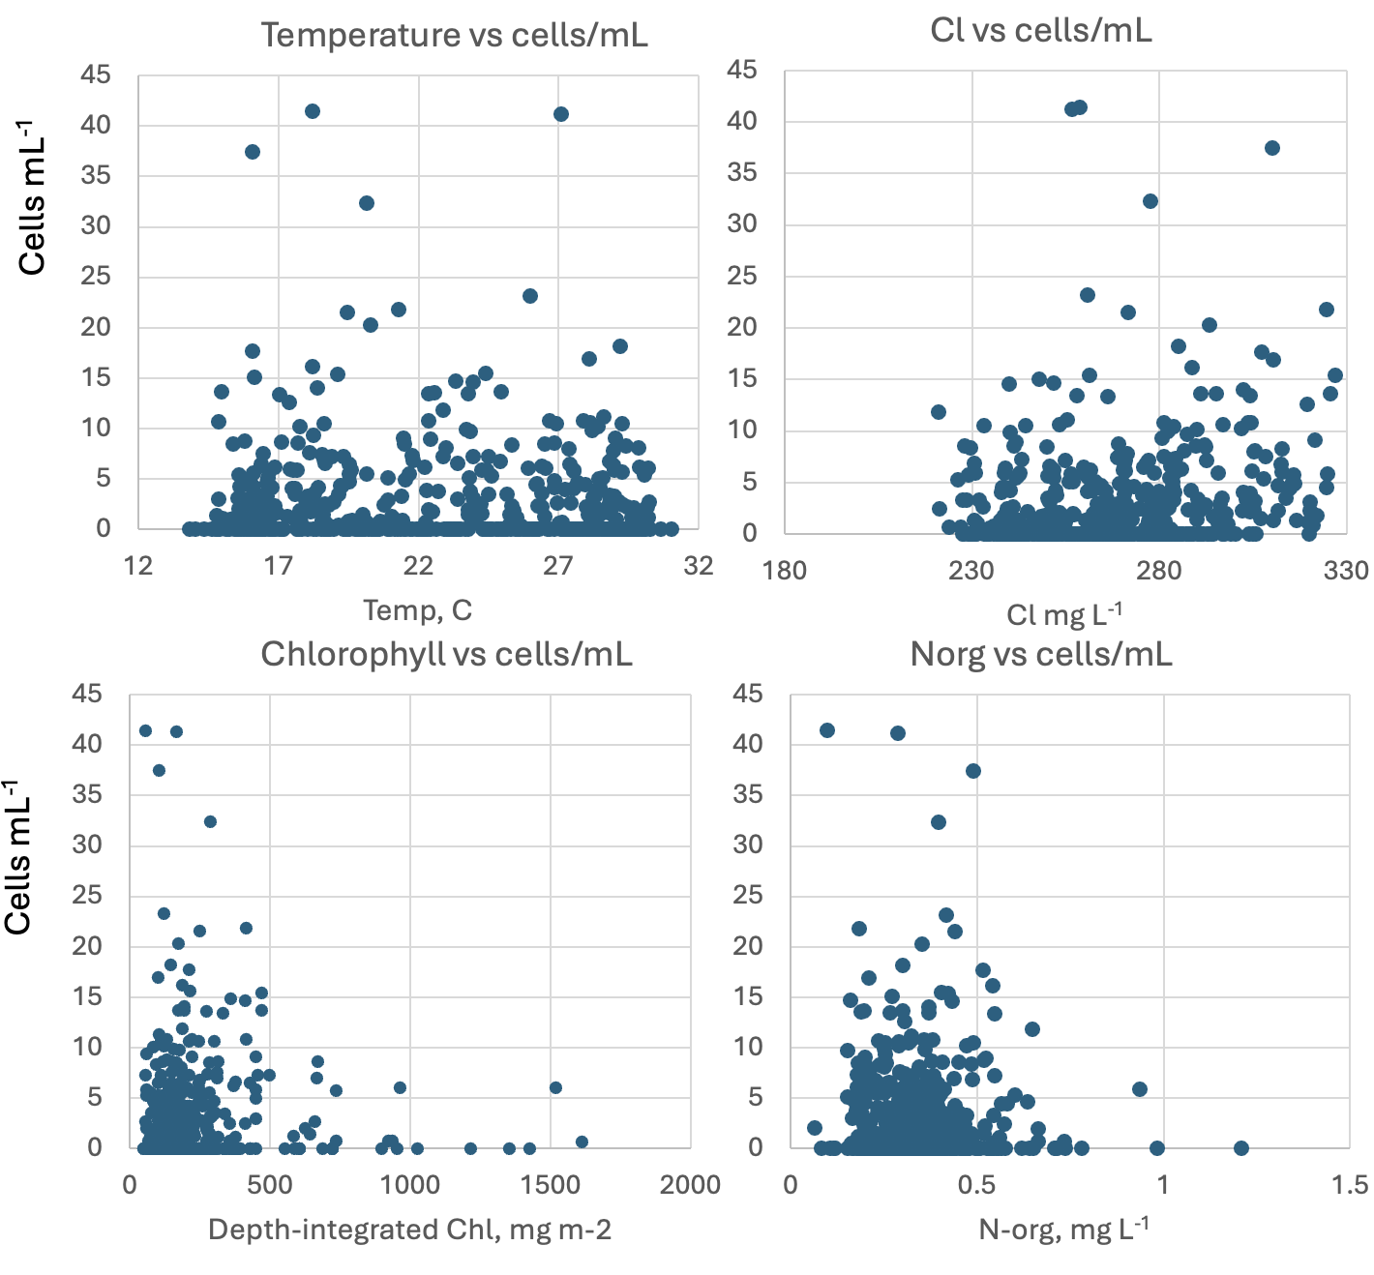
Figure 3. Trachelomonas spp. abundance (cells mL⁻¹) vs. environmental parameters recorded at the site and time of sampling, showing indifference to water temperature (avg. 0-10 m) and ambient chloride concentration, higher abundance at lower chlorophyll (no major bloom of another species), and higher Organic N.
Cite this record as:
Tamar Zohary, Alla Alster. [Date when Item was last updated]. Electronic publication. Israel Oceanographic & Limnological Research. [Date when last accessed].

Colacium Ehrenberg 1833
Phylum: Euglenophyta
Class: Euglenophyceae
Order: Euglenales

Habitat: epibiont on zooplankton
Distinctive features: attached to zooplankton, mostly copepods and rotifers.
Organization: colonies
Color: grass green
Cell shape: oval

Morphological features:
Colacium species are sessile although free-swimming after cell division. The sessile cells are attached to their biotic substrate (zooplankton in Lake Kinneret) with a branching mucilaginous stalk. Several cells are attached each to one of the branches of the stalk to form loosely bounds colonies of several cells. Motile cells look like Euglena: they are naked, with a single emergent flagellum, an eyespot and numerous disk-like chloroplasts. On settling the cells shed their flagellum, rarely divide, and secrete a mucilaginous sheath.
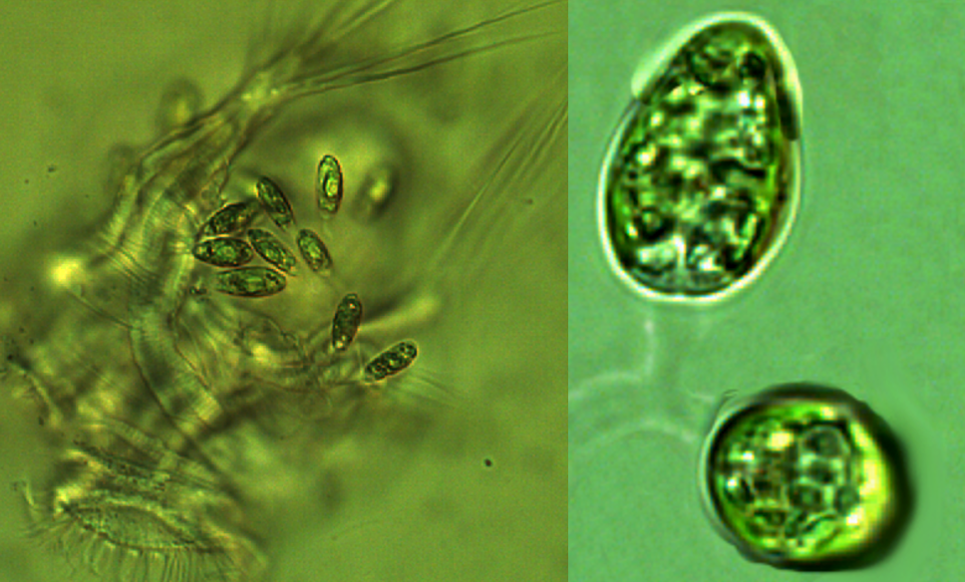
Plate 1. Left: a colony of Colacium attached to a rotifer (probably Hexarthra) in Lake Kinneret plankton. B. details of 2 cells, with their branched stalk. Photos by Alla Alster, 2008.
Ecology: Colacium colonies are occasionally seen as epibionts on zooplankton, especially on copepods and rotifers (Plate 1). Since they are sessile, they are not observed in our phytoplankton samples, were never counted and we have no corresponding environmental data.
Cite this record as:
Tamar Zohary, Alla Alster. [Date when Item was last updated]. Electronic publication. Israel Oceanographic & Limnological Research. [Date when last accessed].

